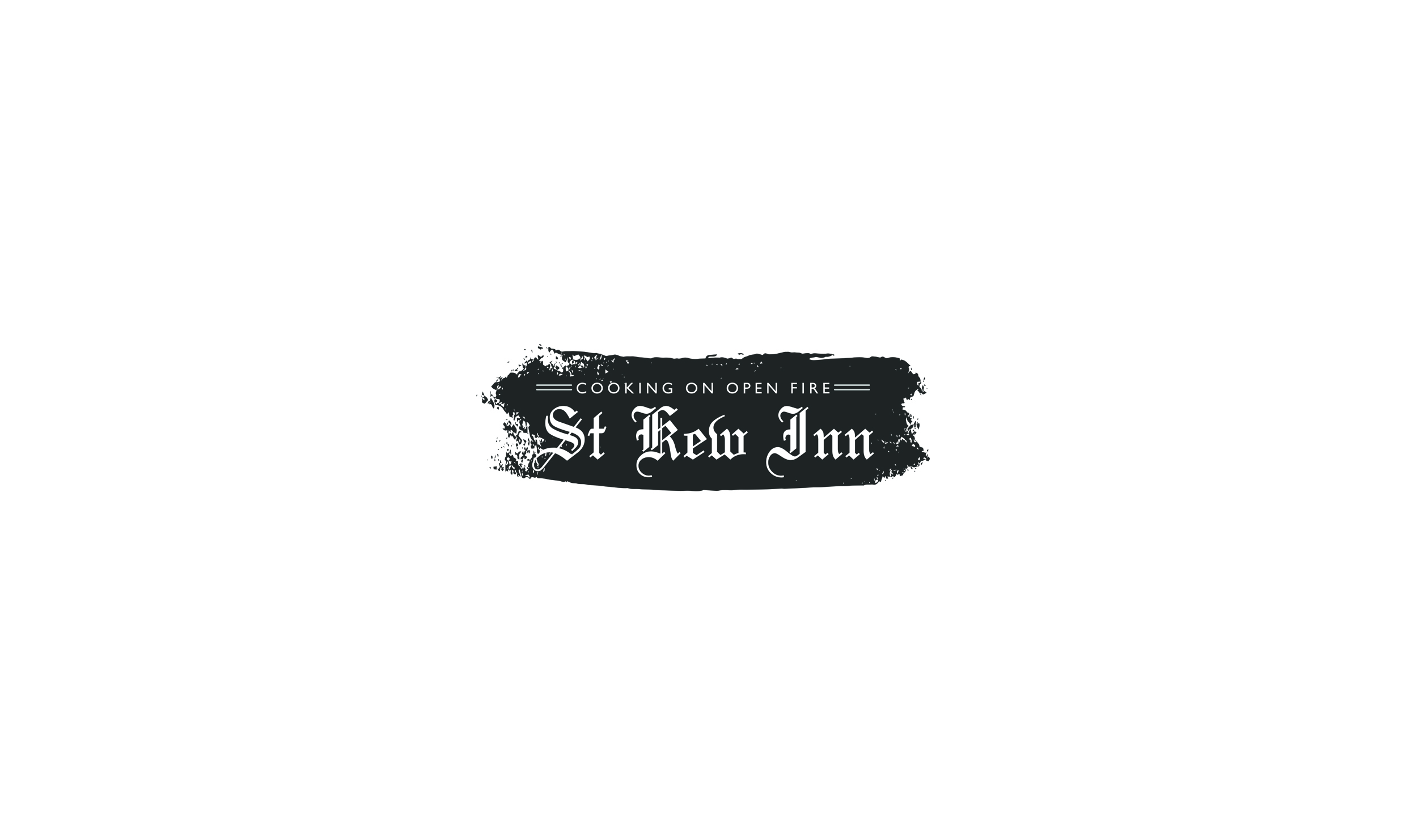

Snacks/Starters
Spiced butternut soup, Coombeshead Sourdough £6.00
Wild mushrooms, cep crème fraiche, parmesan, sourdough £7.00
Beech smoked mozzarella, marinated beetroot, dill and charred leeks £7.00
Crispy buttermilk pheasant, fermented damson ketchup, pickled jalapeno £7.00
Game terrine, celeriac remoulade, sourdough £8.00
Octopus, bone marrow, nduja, ember baked beets, oxeye daisy £8.50
Rock oysters served raw or ember baked £3.00 each or 6 for £14.00
(shallot vinaigrette or beef nduja)

Mains
Beef topside, horseradish sandwich, pickled cabbage, fries £9.50
Ploughman’s, thick cut ham, Davidstow cheddar, ½ pork pie, St Kew chutney £10.00
St Austell Bay mussels, café de Paris butter and fries £15.00
Gurnard on the bone, beef nduja, sea herbs, Cornish mids £18.00
Beer battered haddock, crushed peas, chips, tartare sauce £14.00
St. Kew cheeseburger, beef fat shallots, strong mustard, mayonnaise, fries £14.00
Smoked lamb ragu, Verdi dressing and lamb pangritata £15.00
Roasted aubergine, wilted greens, hummus, spicy nuts, Old Winchester £13.00
Charred vegetable dhal, coriander, yogurt, almonds, lime flat bread £14.00

Dessert
Orange and almond cake, cheesecake cream, citrus curd £7.00
Treacle pudding, toffee sauce, clotted cream £7.00 Custard tart, malt pastry, preserved cherries £7.00
Opera slice, hazelnut ice-cream, shaved caramel chocolate £7.00
Cornish cheese, Trelour, Heligan gold, Helford blue £8.00

If you have any allergies or intolerances please let us know before ordering

St Kew Inn, Churchtown, St Kew, Bodmin, Cornwall PL30 3HB
Telephone 01208 841259

