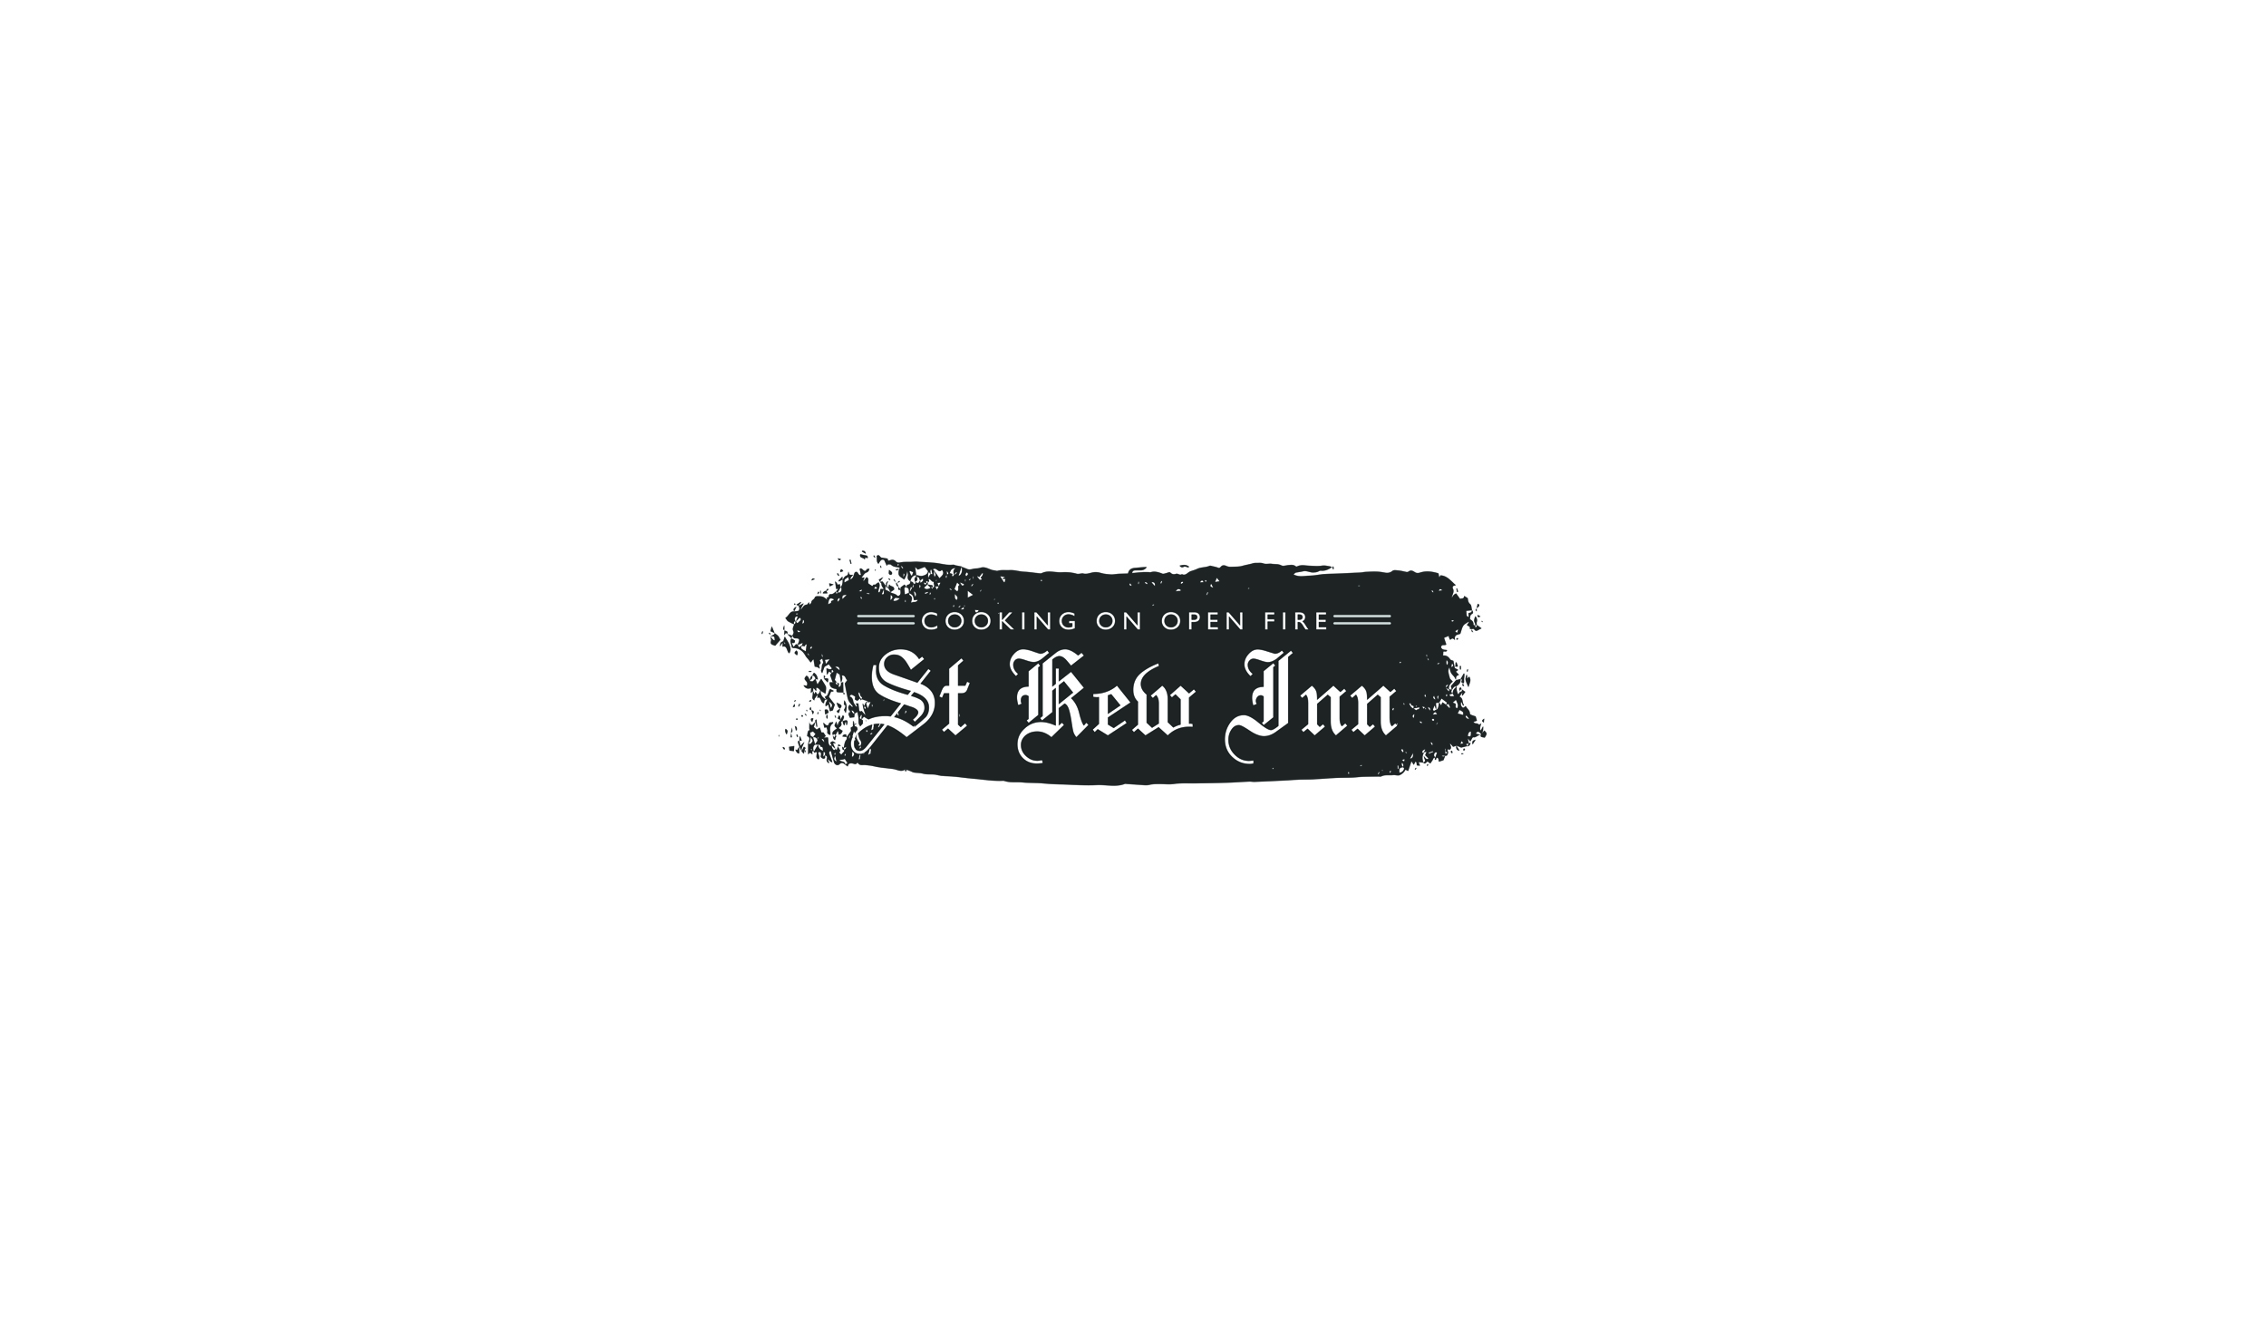

We would like to welcome you to the Inn.
As you can see, things have changed slightly to keep us all safe but this will not dampen your St Kew experience.
It’s great to be pulling pints & lighting fires once more…….

Starters
Da Bara sourdough, onion squash butter £4.00
St Kew marinated nocellara olives £4.00
Padron peppers, labneh, garlic £5.00
Charred octopus, roasted bone marrow, ember baked beets, nduja £10.00
Wild Cornish mushrooms, cep crème fraiche, smoked portobello £8.00
Smoked salmon pastrami, sourdough and pickle £9.00
Black and blue onglet, parmesan, pickled jalapenos, watercress £8.00
Porthilly Oysters - raw with cavolo oil & fermented chilli £3.50 each or 6 for £20.00
- raw with elderberry vinegar
- ember baked with nduja

Mains
12oz Sirloin on the bone, beef fat shallots, smoked mushroom, fries £27.00
Coal roasted day boat fish, St Kew xo butter, charred greens, new potatoes £22.00
Beer battered fish, hand cut chips, crushed peas, jalapeno tartar £15.00
Brown buttered Porthilly shellfish, samphire, fries £18.00
Beech smoked Cornish hot dog, gotcha relish, mustard mayo, beef fat onions,
crispy maris, pickled cabbage, fries £16.00
Blackened squash, fermented chilli greens, hazelnuts, tossed spelt, black garlic mayonnaise, smoked old Winchester £15.00

Puddings
Vanilla panna cotta, flamed elderberries, pumpkin seeds £7.50
Chocolate mousse, smoked caramel £7.50
Strawberry pavlova, clotted cream £7.50
Homemade ice cream and sorbet (3 scoops) £5.50
Smoked Cornish brie, our crackers, St Kew chutney £7.50

St Kew Inn, Church town, St Kew, Bodmin, Cornwall PL30 3HB
Telephone 01208 841259

